**Linked Passages: Preparing Students to Integrate Knowledge Across Texts**ANet Common Core Seminar – December 12, 2013

|  |
| --- |
| **Session Objectives:**   * Understand the relationship between the Common Core standards and linked passages * Identify instructional implications related to linked passages and what level of focus on linked passages makes sense for your teachers in the short and long-term * Name 2-3 next steps for how your school will approach linked passages with teachers |

**Read over the text set and unit focus from this 6th grade LDOE sample sequence:**

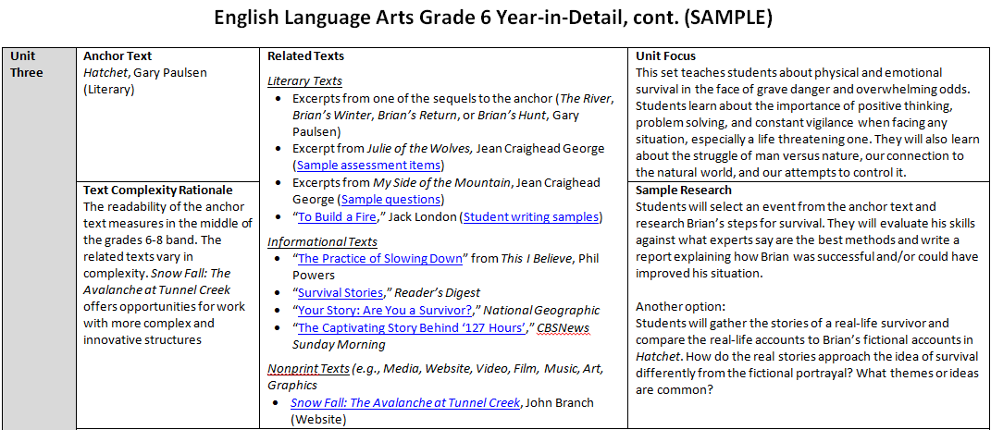

* How do these passages lend themselves to instruction that integrates texts?
* How do these texts support the goals for the unit?

**Common Core Reading Anchor Standards (abridged)**

**Key Ideas and Details**

* R.1 Read closely to make inferences, cite text evidence
* R.2 Central ideas/themes and key details
* R.3 How/why individuals/events/ideas develop & interact

**Craft and Structure**

* R.4 Interpret words/phrases in a text
* R.5 Text structure
* R.6 Point of view

**Integration of Knowledge and Ideas**

* R.7 Integrate/evaluate content from different formats
* R.8 Evaluate argument/claims in text
* R.9 Analyze 2 or more texts

**Range of Reading and Level of Text Complexity**

* R.10 Complex texts

**Vertical Progression of Reading Standard 9 for Informational Text:**

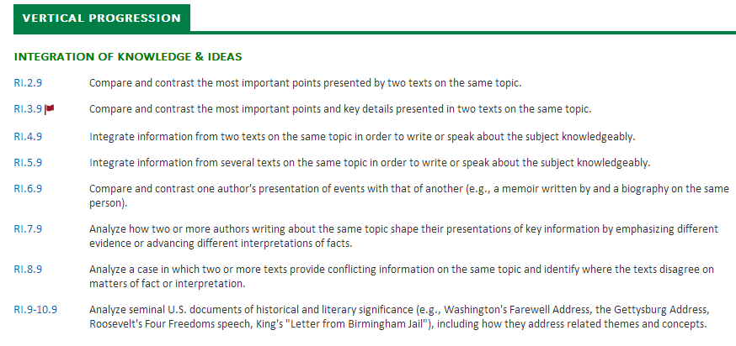

**Determining Next Steps**

|  |  |
| --- | --- |
| **Where are you now?** | **What should you do next?** |
| **1. My main concern is that my teachers don’t panic about linked passages**   * *Teachers have not taught linked passages so far this year.* * *Teachers are feeling overwhelmed with internalizing the ELA standards we have already been focusing on.* | * + - * + Continue to lay the foundation for linked passages:   Prioritize text selection: work with teachers in planning to choose multiple texts with a similar topic/theme (focus on integration in the long-term)  Focus on creating helping teachers craft strong, objective-aligned text dependent questions   * + - * + Provide clear messaging about linked passages possibly appearing on LEAP/iLEAP (and definitely on ANet)         + ‘Stay the course’ on Key Ideas and Details standards in the data meeting         + Provide an optional learning opportunity for interested teachers |
| **2. My school is ready to jump into linked passages on a small scale**   * *Teachers have not taught (OR have not taught very much related to) linked passages so far this year.* * *Teachers are doing fairly well internalizing and teaching the ELA Common Core Standards.* | * + - * + Continue to build teacher skill in purposeful text selection and text-dependent questioning         + ‘Stay the course’ on Key Ideas and Details standards in the data meeting * Designate time during A3 to use the linked passages protocol to build teacher understanding of the standards and related expectations * Begin to set expectations for teachers related to teaching standard 9. Provide feedback on initial lesson plans and lessons dealing with linked passages. |
| **3. My school is ready to go ‘whole hog’ on linked passages**   * *Teachers have had a significant focus on linked passages this year.* * *Teachers are doing well internalizing and teaching the ELA CC Standards.* * *Students are mastering the standards taught (especially standards 1-3).* | * Designate time during A3 to use the linked passages protocol to build teacher understanding of the standards and related expectations * Work with teachers to connect reading with linked passages into writing related to multiple texts * Leverage existing structures/people to maximize linked passage instruction (Sci/SS teachers, guided reading groups, etc.) * Devote time for teachers to “observe the data” for linked passages in the A4 data meeting |

**Based on your school context and the next steps provided, determine:**

* What 1-2 next steps will I prioritize in A3?
* What 1-2 next steps will I prioritize in the longer-term (A4 and next year)?

**Understanding Linked Passages Protocol**

Objectives:

1. Understand the knowledge and skills required for students to integrate knowledge and ideas across multiple passages.
2. Make connections between these items and the instructional priorities you have already been emphasizing with the Common Core Reading Standards to determine next steps for reading instruction.

Materials:

* Interim Assessment with linked passages (Grades 3-8 in A3; all grades in A4)
* Printed Distractor Guide
* *Optional: Note-taking Template*

Agenda:

1. **Read through the passages that are part of the linked passages section of the interim.** *10 minutes*

* Why are these passages linked? What are their similarities?
* How are these passages different?

1. **Answer the items that assess multiple passages.** *5 minutes*

* These are found after the items aligned to the final linked passage.
  + What do these items reveal about what knowledge and skills students need when they are reading and answering questions about linked passages?

1. **Analyze the aligned standard for each linked passage item.** *5 minutes*
   * Does the language of the standard further illuminate what students must know and be able to do to answer this item successfully?
   * What does the standard further clarify about Common Core reading mastery?
2. **Compare and contrast these items with non-linked, single-passage items.** *5 minutes*
   * How are the knowledge and skills required in linked passages items similar to and different from items assessing only one passage?
3. **Define instructional implications**. *5 minutes*
   * What instructional moves would lead students to be able to integrate knowledge and ideas across multiple texts and successfully answer items like these?
   * How could instruction with linked passages support student mastery of standards other than Standard 9?